SRF State/EPA Workgroup
8:30 AM – 12:00 PM
__________________________________________________________________________________________

William Ruckelshaus Conference Center
Colorado Room
1201 Constitution Ave., NW
Washington, DC 20004

Please try to get to EPA by 8 am or shortly after. Enter the EPA East Building at 1201 Constitution Ave., NW to go through security. EPA will have staff there to escort you to the conference center.
__________________________________________________________________________________________
Directions
If you are traveling by metro, take the blue/orange line to Federal Triangle. When you exit the station, walk toward 12th Street, NW (It should be directly behind you/away from Woodrow Wilson Plaza). Make a right onto 12th Street. Make a right onto Constitution Ave, NW. The 1201 Constitution East Entrance will be on your right.
Note that if you go down the steps in Woodrow Wilson Plaza, you will find Timgad Café and Market to Market for coffee and breakfast items. There is also a Panera in the Ronald Reagan Building. The Ronald Reagan Building is open to the public, but you will have to go through security to access that building. I think that there may be vending machines in the conference center, but I would recommend bringing a water bottle.

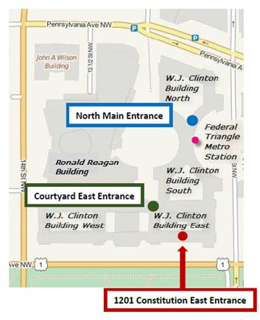
PROPOSED AGENDA
- Introductions (15 min)
- CIFA Workgroup Engagement Process (30 min)
  - Any proposed changes to grant agreements and contract requirements need to come to the workgroup prior to adoption
  - reasonable expectations for work group
  - streamlining avenues for communication (narrower focus and workgroup attendance)
- 8th DWINSA (30 min)
  - Timeframes
  - LSL/EC considerations vs other needs
  - allotments used for 5th year
  - consideration of unserved areas with known contamination
- Timely and Expeditious – both EC and LSL (45 min)
  - LSL – Funding not moving as quickly as hoped due to several factors
    - Inventory due date was well after the start of the IIJA funding
    - Communities trying to verify all of their unknowns
    - Ramifications for DWINSA
  - EC – Projects delayed based on several factors
    - Sampling taking time
    - Significant Technical Assistance needed
    - MCL finalization – deadlines keep being extended, but continued pressure to get the $$ out faster
- State specific coordination issues tied to technical assistance (30 min)
  - States to share specific examples
  - Coordination challenges tied to RealWaterTA, SWIFT and TEC TA
- Timing of notifications of funding allocations and the expedited dates for awarding funds (30 min) - States are feeling the burden to have their processes align with the new shift in the timelines, resulting in delays in PPL's, IUP's.
- OIG report on improper payments – EPA responses to report (15 min)
  - How much information are the states giving to EPA and how to right size.
- Member Issues / Wrap Up (15 min)

